Practical No. 4
Aim : 3) WAP to check if the input year is a leap year or not

Name : Danish Altaf Solkar | Class : CO - B
Enrolment no. : 24111590805 | Batch : 2

Code :-
year=int(input("Enter a year : "))
if(year%400==0)or(year%4==0 and year%100!=0):
print(year," is a Leap year.")
else:
print(year," is not a Leap year.")

OUTPUT :-
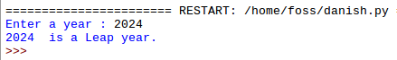

Process related  (30) | Product related  (20) | Total Marks  (50) | Signature

